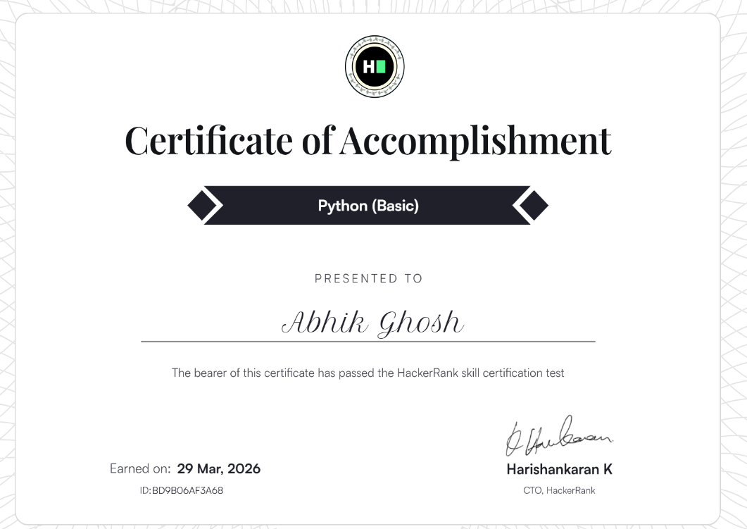
https://www.hackerrank.com/certificates/bd9b06af3a68

